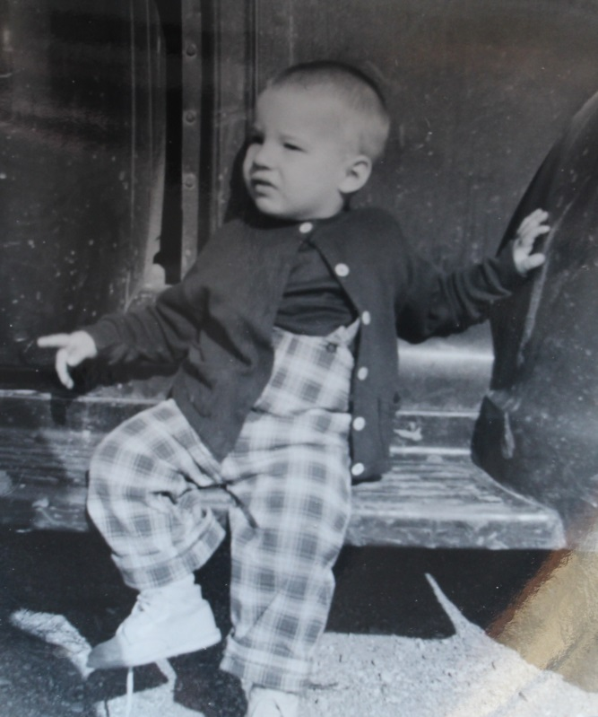

Stephen Ronald List – son of Ronald & Jo Ann List

born 20 May 1956, died 18 January 1958

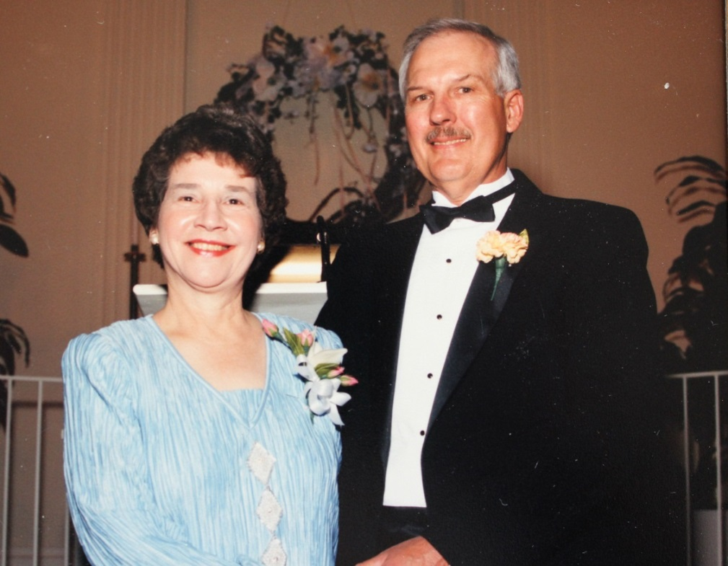

Jo Ann and husband, Ronald List – 1989